

**LATTE STATISTICS:**

BLENDING INFORMATION FOR A SMOOTHER PROCESS

SEEMA TANVEER SYED

24205868

**MAP FULFILMENT PROCESS: KEY STATISTICS:**

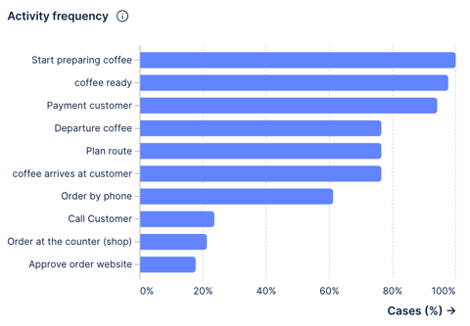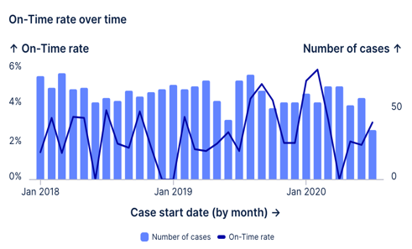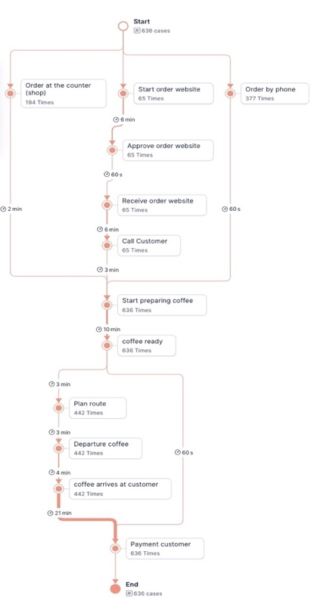

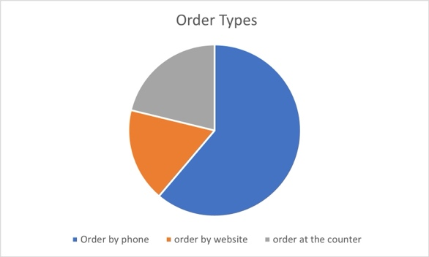

**BOTTLENECKS:**

**Unwanted activities per case over time:**

The on-time rate graph shows that the coffee shop's performance in delivering coffee on time fluctuated between 0% and 6% from 2018 to 2020. The number of cases per month stayed relatively consistent, with occasional peaks, but on-time rates exhibited more volatility, especially towards the end of 2019 and early 2020, where significant drops are evident.

**Bottle necks:**

Call customer: Reduce calling customers over and over again as this increases the total throughput time significantly. Need to come up with a system to register a call order perfectly.

Website: Website orders are inefficient, with low frequency and lengthy throughput times. Despite fewer users utilizing the website, the process remains lengthy, contributing to congestion. (Activity Frequency Graph)

Order placement (over the phone, at the counter, or on the website) is the first step in the coffee fulfilment process. Approval, preparation, delivery, and payment come next. The map provides insights into areas for efficiency and improvement by highlighting significant stages, durations, and fluctuations. This graphic depiction aids in workflow optimisation and bottleneck identification.

**Activity Frequency** :The activity frequency graph demonstrates that the most common operations in the coffee shop process are preparing coffee, marking it ready, and processing customer payments, which all approach 100%. Approving website orders and phoning consumers are among the least common actions, demonstrating that online and direct client interactions occur less frequently than in-store chores.

**Variants:** The pie chart shows different variants of the process, which are via phone, website and counters.

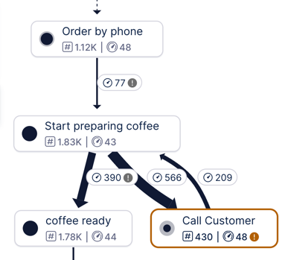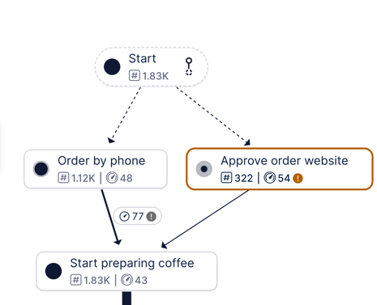

**Opportunities arising for business:**

* Using promotions such as combo deals on high-spend days to boost revenue during peak hours.
* The weather has a substantial impact on order volume, with snowy days seeing the fewest orders. To boost delivery efficiency, the coffee shop can change employee shifts and shorten delivery routes on such days.

The day with the highest total customer demand is **May 25, 2019**, with a forecasted demand of approximately **524 customers**.

**Constraints**:

* Courier Cost: Each courier charges €15 per hour.
* Courier Capacity: Each courier can cover up to 25 miles per hour.
* Delivery Range: Deliveries are within a 10-mile range.
* Max Couriers: A maximum of 10 couriers can be on shift at any one time.
* Operating Hours: The shop is open from 7 AM to 7 PM (12 hours of operation per day).

The following constraints are defined by these variables:

* Let $x_{i}$ ​ be the number of couriers working during hour *i*, where *i* =1,2…,12 for each hour between 7 AM and 7 PM.
* Total Cost=15× $\sum_{i=1}^{12}{x_{i}}$
* Total delivery distance: $xi​≥di/25​​$ where *di* is the distance to be travelled divided by 25 miles (max capacity).

Calculating using these values we get a table that provides us with couriers required per each hour:

|  |  |  |
| --- | --- | --- |
| Hour | Required Couriers | Total Delivery Distance |
| 7 AM | **2** | 45 |
| 8 AM | **3** | 60 |
| 9 AM | **3** | 55 |
| 10 AM | **3** | 70 |
| 11 AM | **4** | 90 |
| 12 AM | **4** | 85 |
| 1 AM | **4** | 100 |
| 2 AM | **5** | 110 |
| 3 AM | **3** | 75 |
| 4 AM | **3** | 65 |
| 5 AM | **2** | 50 |
| 6 AM | **2** | 45 |

This makes the combined total number of courier hours as 38. With each courier being paid €15. The total cost comes out to be 15 x 38 = €570.

The optimization formula for this problem is $15×\sum_{i=1}^{12}{x_{i}}$ where $x_{i}≥di/25​​$. Where the optimal objective function value is

Therefore we need high number of couriers to be on shift during the time periods of 11 AM to 3 PM where the order magnitude was extremely high for this day. We could incorporate a dynamic delivery courier shift assigning on a daily basis through future forecasting. This would optimize the number of courier requirement and significantly reduce the logistical expense for the café.